**Market Analysis Report for National Clothing Chain**

**Summary of Result**

Analysis of Research Questions:

What is the correlation (R2 value) between sales and income?

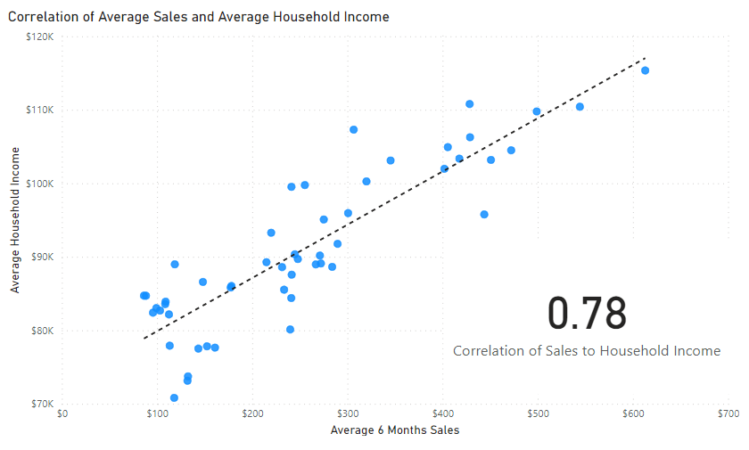The correlation between sales and income is 0.78, indicating a positive and good relationship between the variables. As income level increases, the sales level increases. Hence, at 0.78 R2 value, variation in sales can be largely explained by variation in income.

What is the correlation (R2 value) between customer ratings and product return rate?

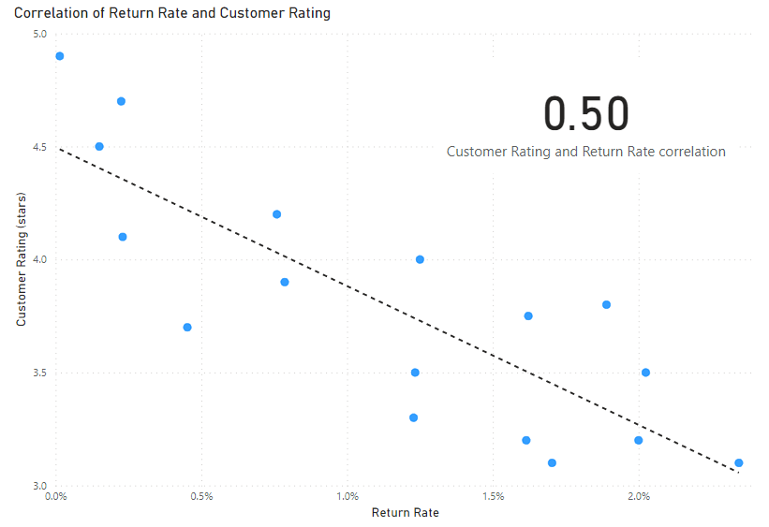The correlation between customer rating and return rate is 0.50. the graph below shows an inverse relationship between these variables. As level of return rate increases, the ratings become poorer

What are the linear regression formulas to predict customer income from customer sales?

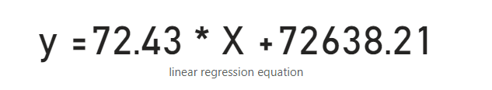The linear regression formula is given as; Y = 72.43X + 72,638.21

Which customer do you predict has the highest income?

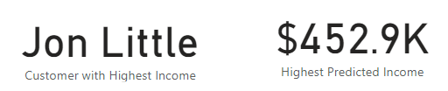The customer with the highest predicted income is Jon Little with an income of $452,895.1

Which product will be advertised the most?

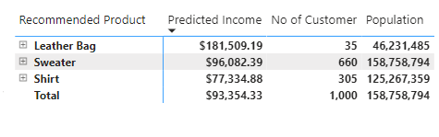Sweater will be the most advertised product, given that it has the highest number of customers based on predicted income

**Conclusion**

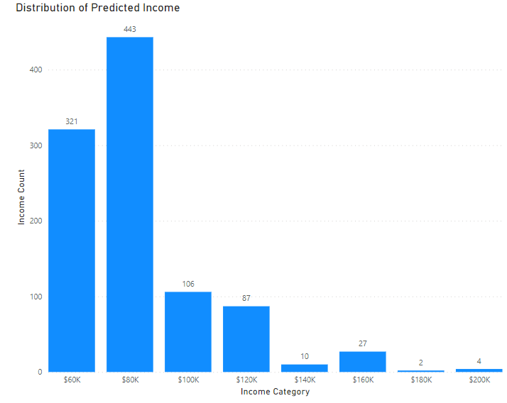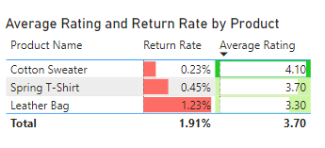After analyzing the historical sales records of customers across the different states in the US, it was observed that statistically, as the average income of household increases, consumer buying behaviors improves. Consumers within the average income below $100k are the big spenders and are represented by the left-skewed histogram below.

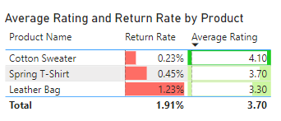Though, the product with the highest predicted average income is Leather bag, Sweater appears to be the most recommended products based on the number of customers. In addition, it is the product with the least return rate as shown below.

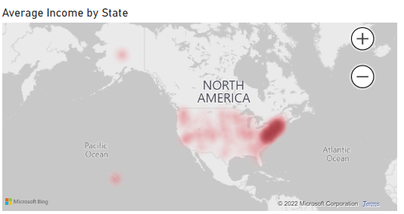The household income is highly concentrated around the South Eastern America as shown below.

Recommendations

We recommend that marketing efforts should be focused to capture more customers with average income below $100k who resides around the South Eastern part of the United State. The Sweater product has been recommended and should be improved upon to ensure the customer rating is improved upon for more adoption.

The Leader Bag product should having the highest price should be marketed to the customers living in the following states; California, Texas, New Jersey and Illinois as customers within these location have higher income than other location.